Grade 7 Accelerated · Unit 3  Unit 3 Review  Exponents and Scientific Notation ANSWER KEY | Name  Date  Period

Show your work. Circle your final answer.
HOW TO USE THIS. This review covers every learning target from the unit — more than the assessment does. Work it in parts. If you miss two or more in a part, that part is where to spend your study time. The reference sheet has everything you need for each part.
PART A. Product, Quotient and Power Laws Lessons 1–3 · MA.7.NSO.1.1 · 8 questions
1. Write as a single power: 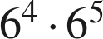

Like bases: add the exponents. The base stays 6.

2. Write as a single power: 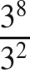


3. Write as a single power: 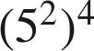

Power of a power: multiply the exponents.

4. Find the value: 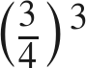

Power of a quotient: raise the top and the bottom.

5. Find the value: 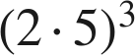 and 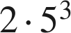. Are they equal?
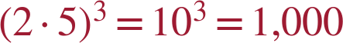; . No.
Without parentheses only the 5 is cubed.

6. Find the value: 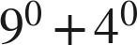
2
Each zero power is 1, so 1 + 1 = 2 — not 0 and not 13.

7. Find the value of : 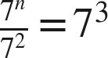
n = 5
n − 2 = 3.

8. Which expression is equivalent to 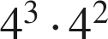 ?
● A. 
○ B. 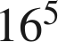
○ C. 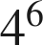
○ D. 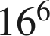
A

PART B. Zero and Negative Exponents Lessons 4–5 · MA.8.NSO.1.3 · 7 questions
9. Rewrite with a positive exponent: 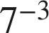


10. Rewrite with a positive exponent: 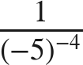
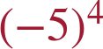
The power moves up; the base keeps its parentheses.

11. Find the value: 

Reciprocal of 3⁴. Not −81 and not −12.

12. Find the value: 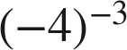
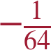
1 over (−4)³ = 1 over −64. The sign comes from the base.

13. Find the value: 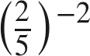

Flip the fraction, then square it.

14. Find the value: 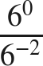
36
0 − (−2) = 2, so 6². Or: 1 over 6⁻² is 6².

15. Find the value of : 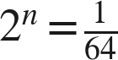
n = −6

PART C. Evaluating and Equivalent Expressions Lessons 6–7 · MA.8.NSO.1.3 · 5 questions
16. Find the value: 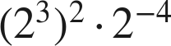
4
2⁶ · 2⁻⁴ = 2².

17. Find the value: 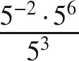
5
−2 + 6 − 3 = 1.

18. SSDD. Every part below is about the expression 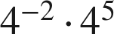. Same surface, four different questions: rewrite, evaluate, judge an equivalence, solve for an exponent. Only part c has a yes/no answer and only part d has a negative one.
a. Write it as a single power.

−2 + 5 = 3.
b. Find its value.
64
c. Is it equivalent to 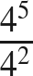 ? Explain.
Yes — 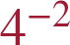 is , so the product is 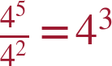 either way.
d. Find so that 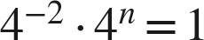.
n = 2
−2 + n = 0.

19. Select ALL of the expressions equivalent to 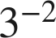.
☒ A.
☒ B. 
☐ C. 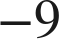
☒ D. 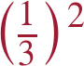
☒ E. 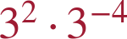
☐ F. 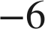
A, B, D and E

20. Aryella says that 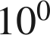 and 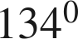 are equal. Is she right? Explain.
Yes. Any nonzero base to the zero power is 1, so both equal 1.

PART D. Variable Bases Thread A, days 1–2 · MA.8.AR.1.1 · 8 questions
21. Write as a single monomial: 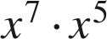
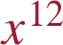

22. Write as a single monomial: 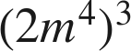

The 2 is cubed too.

23. Write as a single monomial: 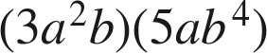


24. Write as a single monomial: 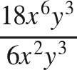
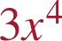
y³ over y³ is y⁰ = 1.

25. Rewrite with positive exponents only: 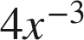
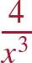
Only the x moves.

26. Rewrite with positive exponents only: 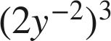
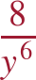

27. Rewrite with positive exponents only: 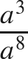

3 − 8 = −5.

28. Which expression is equivalent to 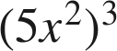 ?
● A. 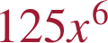
○ B. 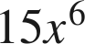
○ C. 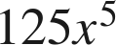
○ D. 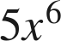
A

PART E. Large Numbers in Scientific Notation Lesson 8 · MA.8.NSO.1.4 · 5 questions
29. Write 7,400,000 in scientific notation.


30. Write 205,000,000,000 in scientific notation.

The interior zero stays in the coefficient.

31. Write 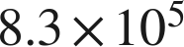 in standard form.
830,000

32. How many times larger is 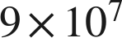 than 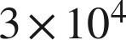 ?
 times
9 ÷ 3 = 3 and 10⁷ ÷ 10⁴ = 10³.

33. Dana writes 45,000 as 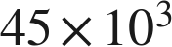. Is her expression equal to 45,000? Is it scientific notation? Explain.
Equal, yes. Scientific notation, no — 45 is not less than 10. The correct form is .

PART F. Small Numbers, and How Many Times Lesson 9 · MA.8.NSO.1.4 · 6 questions
34. Write 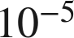 as a decimal.
0.00001
A 1 in the fifth decimal place.

35. Write 0.00093 in scientific notation.
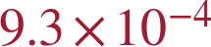
The 9 is in the fourth decimal place.

36. Write 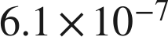 in standard form.
0.00000061

37. Which is greater, 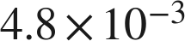 or 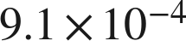 ? Explain.
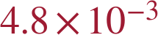 — the exponent −3 is greater than −4; 0.0048 > 0.00091.

38. How many times larger is 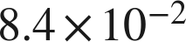 than 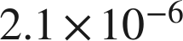 ?
 times
8.4 ÷ 2.1 = 4 and −2 − (−6) = 4.

39. A computer displays a number as 2.7E−5. Write it in scientific notation and in standard form.


